Name: Jagtap Shivraj Vaibhav
Roll no: EN24107060
Class: SY- AI&DS – A
Subject : Robotics and Automation (MDM)
______________________________________________________________________________________________

Experiment No:4
Title: Demonstration of SCARA robot.

Introduction:
The SCARA robot (Selective Compliance Articulated Robot Arm) is a type of industrial robot that is designed for high-speed, high-precision tasks in manufacturing and assembly processes. It is characterized by its selective compliance, which allows flexibility in the horizontal plane while maintaining rigidity in the vertical direction. This unique feature makes SCARA robots ideal for tasks such as pick-andplace operations, assembly, and material handling. The SCARA robot operates in a cylindrical work envelope, which gives it a compact design with excellent speed and precision. In this study, we will explore the structure, motion,work envelope, and key applications of SCARA robots.

Image of SCARA robot:

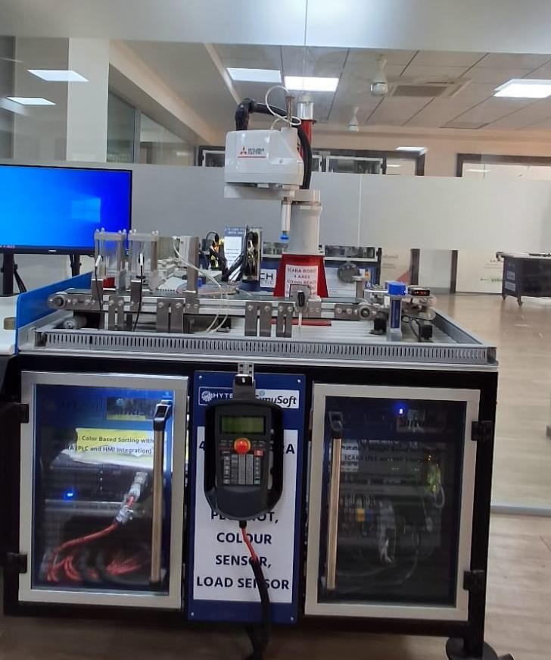

Fig 1

• Applications of Scara Robot in various industries:
3 cases :

1 . Electronics Component Assembly
One of the most common uses of a SCARA robot is in electronics manufacturing. In this process, the robot picks small electronic components such as resistors, capacitors, and integrated circuits and places them accurately on Printed Circuit Boards (PCB). The SCARA robot performs these tasks at very high speed and with great precision. This reduces human error and increases production efficiency in industries that manufacture electronic devices like computers, mobile phones, and control system.
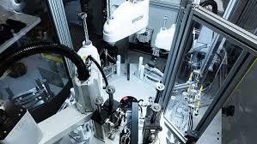

Fig 2

2. Pick and Place in Manufacturing
SCARA robots are widely used for pick-and-place operations in manufacturing industries. The robot arm picks parts or products from one location, such as a conveyor belt, and places them in another location like an assembly station or packaging unit. Because of their fast movement and repeatable accuracy, SCARA robots can perform this operation continuously without fatigue. This helps increase production speed, reduce manual labor, and improve consistency in industrial production lines.
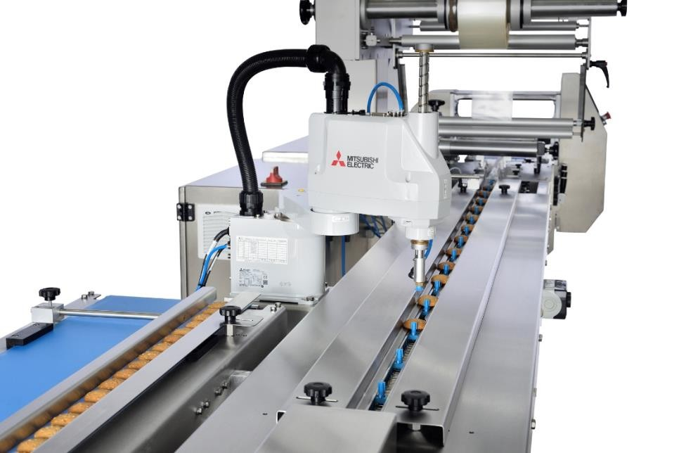

Fig
3

3. Packaging and Sorting of Products
SCARA robots are also used in packaging and sorting applications in industries such as food processing, pharmaceuticals, and consumer goods manufacturing. The robot can quickly pick products from a moving conveyor belt and place them into boxes, trays, or containers for packaging. In pharmaceutical industries, SCARA robots handle medicine bottles, tablets, and medical components carefully and hygienically. Their high speed and precision make the packaging process faster and more efficient while maintaining product quality.
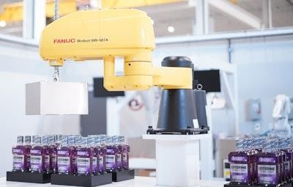

Fig 4

Conclusion: The SCARA robot is widely used in industries for high-speed and precise operations such as assembly, pick-and-place, and packaging. It improves productivity, accuracy, and efficiency in automated manufacturing systems while reducing human effort and errors.

